Database
Model for a Commercial
Airline Service

By James Fefes, Eugene Nicks,
Andrew Hotchkiss and Andrew Morrison

Table of Contents

- Cover Page
- Table of Contents
- Introduction and Description of Business Process
- Schema
- E/R Diagram
- DBMS, Programming Language, and References
- Screenshots
- Conclusions
- Appendix: User Guide, Installation Recommendations

Introduction

We decided to model a database for an airline service, that will manage and track employees, plane information, flights, and customer information. Our task was to develop a relational database with a client-side interface to store and utilize the data. The design process included researching the processes and challenges in an airline database, identifying relations and putting them in an ER diagram, creating a schema, and implementing software to communication with this database. Some of the challenges we faced and solved along the way were enforcing referential integrity, designing a method to organize seating, and creating views for different parties.

Description of Airline Business Processes

Commercial airlines provide the service of transporting large numbers of people in airplanes. Managing an airline as a whole requires that information is regularly updated on employees, planes, customers and flights. Typically, airlines sell tickets to reserve a seat on a flight for a designated time and date, and receive payment for the ticket. Customers are assigned seats on a flight depending on their departure and destination locations and sometimes other factors like seating class. They go to their designated gate at the time on their ticket and board, whereupon the plane takes off. The flights carry not only customers but employees, who need to be tracked, and flights need to be coordinated to avoid crashes and mix-ups on the runway. In addition, flights need to be coordinated with other airports for landings and layovers. All of these things are recorded and communicated to the interested parties in a convenient manner.

Schema

Key: Flight_Num – Underlined is Primary Key
En_Route* - Denotes binary attribute

Flights-
Flight_Num, Dest_Port_ID, Current_port_ID, Departure_T, Arrival_T, En_Route*, Gate_D, Gate_C, Seats_Max

Employees-
Em_ID, FName, LName, Title, Salary

Customers-
Cust_ID, FName, LName, Flight_No, Seat_No

Airports-
Port_ID, City, State
Entity/Relationship Diagram

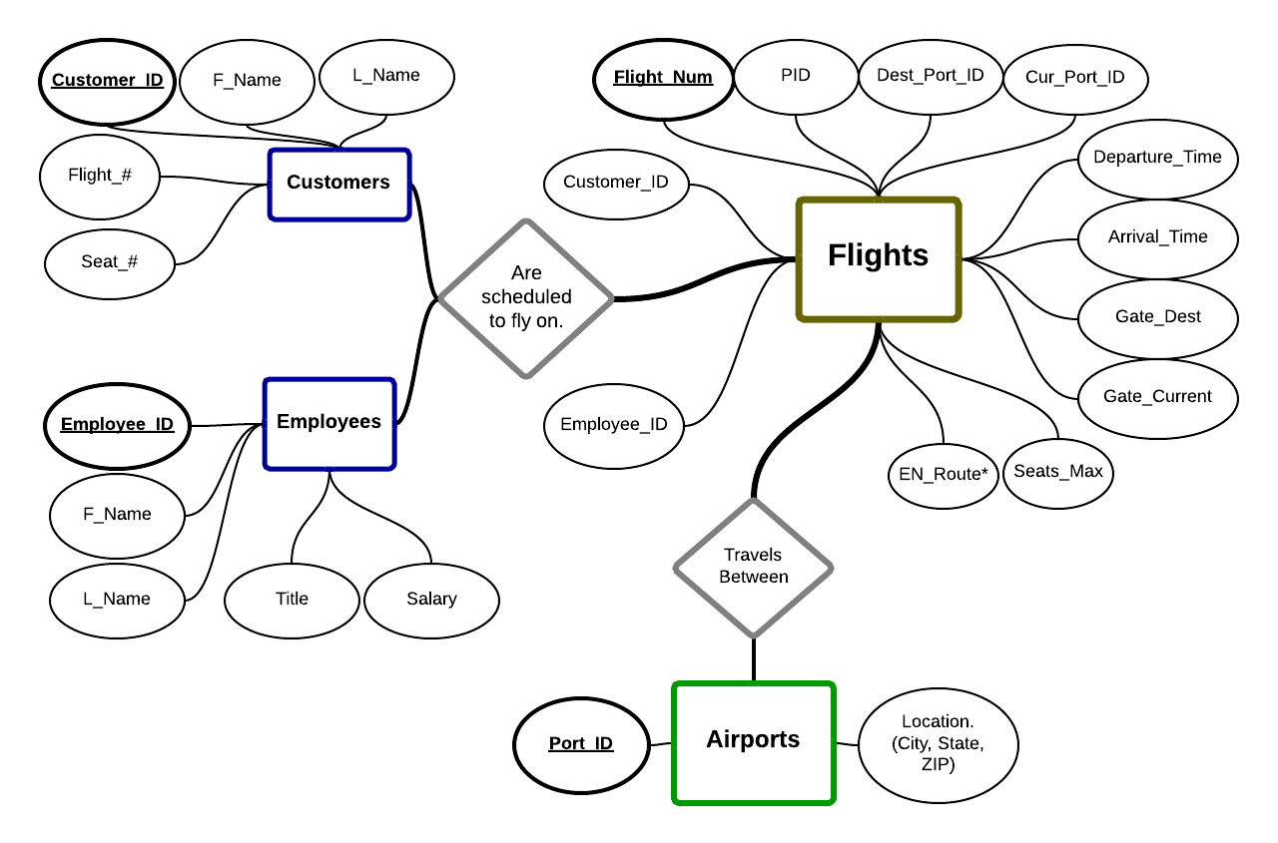

Programming Language

We decided to use PHP to connect to our database and create the individual views. The GUI utilizes a menu with submenus for navigation. Each submenu is an approach of a unique view. For example, the pages in the Customer submenu are designed to be the only pages a customer would have access to. This style of interface provides convenience for the user, manages division of data for the database, while maintaining a single site for programmers and admins to modify and test the software. In the real world, these sites would be divided, if not written separately to provide the most usability to each Use-Case scenario.

Our site utilizes class-object inheritance and include statements on each page, similar to a design pattern. This provided our group with several benefits, as each viewed page includes three Include files, named Site, Page, and Template. The Site Include file contains the php-based layout, including header options, the menu itself, and footer options. The second Include file, page, is the parent for every viewable page. At the end of each page, a new object is created containing the implementation of a Page child. Together, the child object and Site code are sent to template. Template itself contains the statements to include all of the css and javascript files, and it is within Template that the methods for the page object are called. Following this method, none of the source code (such as SQL commands, database connection info) is visible by viewing the page source in a web browser. Examples shown in the Screenshots section of this documentation.

Oracle

We continued the use of Oracle as our DBMS, through the Oracle Call Interface for PHP, commonly referred to as OCI. After identifying all necessary entities and relationships, we added the attributes and set primary and foreign keys. Appropriate constraints were added, as well. Special cases include referential integrity constraints in cross-referencing flights, with the most unique being a check for the binary ‘En_Route’ attribute. This attribute returns a 1 (true) when the target plane is currently in flight, and a 0 (false) when it is on the ground. The idea behind this was that customers and employees are unable to change flight information if it includes adding or removing a flight that is currently in the air. Thus, En_Route becomes a flag for preventing these real-life errors occurring.

Screenshots
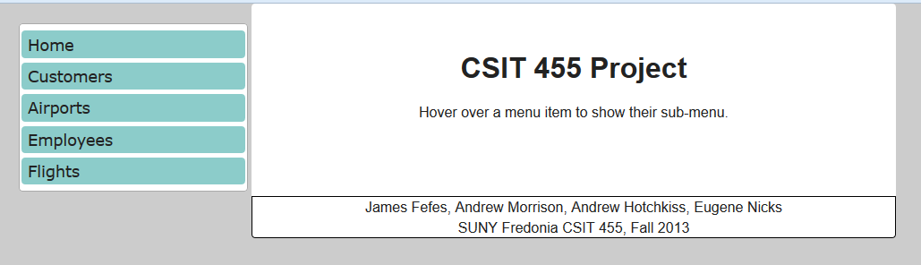
File: index.php
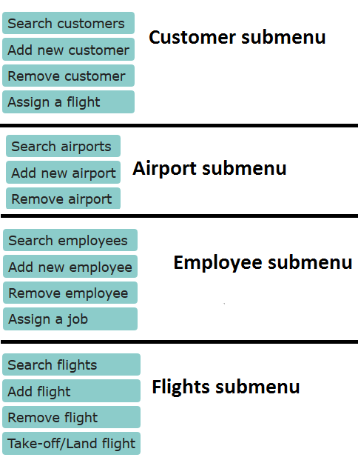
Shown: Menu on the left, footer on the bottom, both from /Includes/Site.inc
(On right)

Shown: Each submenu. These submenus extend to the right of their menu, demonstrated again below.

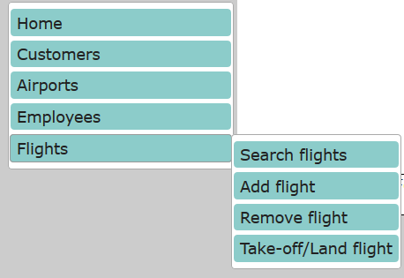
Shown: Flight submenu as it extends to the right of the main menu. Again, submenus are only shown when the mouse is hovered over a submenu's respective category.

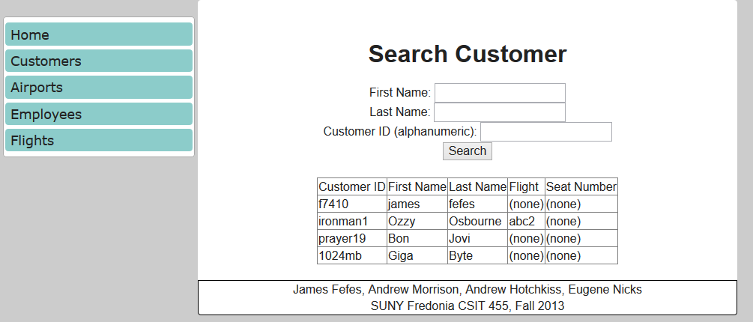
The following section contains three screenshots of the same page: 1- as viewed through a browser, 2- source code from the php file and 3-the body, viewed through the “Show source” option in a web browser. As explained earlier, vital source code, such as the database connection info, SQL commands, and methods of collecting data to/from the database will be ran on the page (Shot 2), but will not be viewable under a “View source” mode (Shot 3).
File: /customers/seach_cust.php

Shown: Shot 1, as viewed in browser.

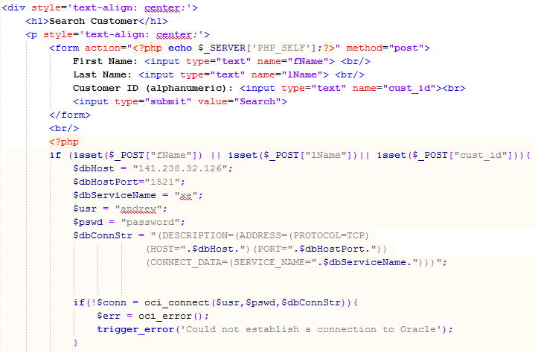
File: /customers/search_cust.php

Shown: Screenshot 2. This code snippet is from the source itself. As shown, immediately after the form code is generated, php is used to create a connection. On a web page not following an approach similar to ours, the php code would be viewable from a web browser's “Show source” mode.
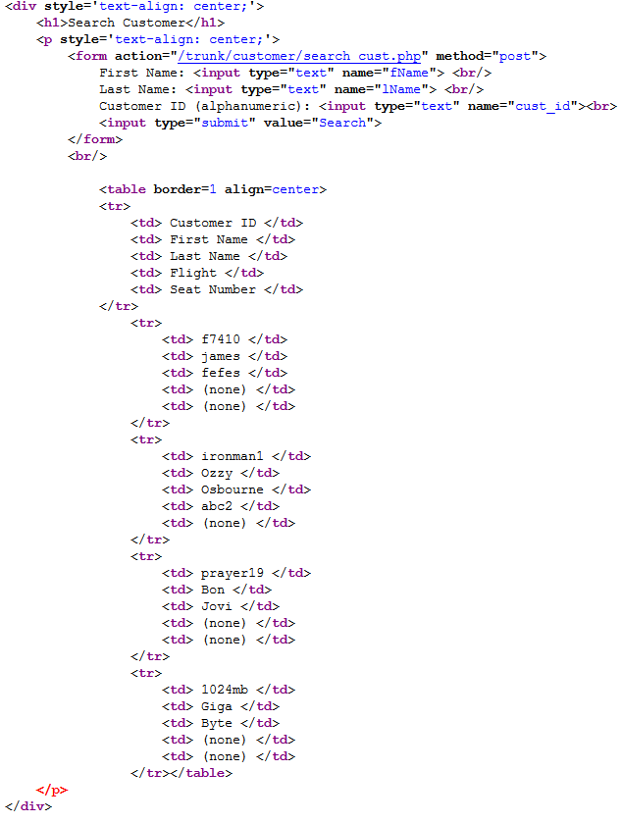
File: /customer/seach_cust.php

Shown: Screenshot 3. As promised, the php code (and therefore OCI/SQL commands) this increases security of the project. If this page were to be launched as a real-world application, the login credentials would not be part of the accessible source code from a browser.

Conclusions

This project strongly demonstrated the gap between a real-world application of a firm's database and a class simulation. As a class assignment, it is acceptable to assume that a user is informed on how to operate the created software, which allows for lee-way in validation of inputs. However, with a real-world airline website, the weakest link between the implementation of software and the usage of finished software is the human factor. As an airline service designing the same software we have created, every single input would have to closed watched for both validation and for security loop-holes.

The only real parts of this project that could be added are these validations to protect against human error, however, as the system is, input data cannot be manipulated into corrupting any entries of the database. Similarly, individual pages could manage more information to appear as more like a real-world firm's website. For example, when registering as a new customer, a password, CAPTCHA, and email validation system would typically be implemented. However, these are outside of the scope of the project.
User Guide

There are four different sections of the website, named Customers, Airports, Employees, and Flights. Each of these sections has multiple pages to them, three of which are the same: Search, Add, and Remove. Customers, Employees, and Flights have four pages These unique pages will be explained separately.

Search pages always open in a new tab. On a search page, an input box is given for each of the attributes that can be used as search criteria. Any combination of these inputs may be used, from as many as all of them, to as little as one. As an example, the search inputs for Employee are Employee Id, first name, last name, job title, salary, and job assignment. The value of 'Smith' can be input as last name, and 'Pilot' can be used as the input for job title. When the search button is pressed, the only results that will show are those whose last name equal Smith and whose job title equal Pilot. If no inputs are given, the SQL statement “select * from employees” will be sent to the database instead, displaying any employees.

Add pages work similar to Search pages, however all inputs must be filed in. If a single input is left blank, no queries will be executed. If an error occurs while typing in data and remains in an input box when the data is submitted, a related sql error statement will appear. If no errors occur, the data will be inserted into the database, and a message will appear briefly explaining the new entry you created.

Remove pages look much more simple than an Add page, only one input is required, which is the unique ID of the Customer/Airport/Employee/Flight you are looking to remove. Errors will occur if part of the entry you are trying to delete is referenced as a foreign key in another table. (For example, if you try deleting a flight that has customers assigned to it, the error message will appear.) This error message will display the constraint that is being violated. If no errors occur, a message will appear briefly describing the entry that was deleted. If the input is left blank, then no queries will be ran.

In the Customers section, the fourth page is for assigning and reassigning customers to a flight. On the add page, no flight is required in order to create a new customer entry, which simulates an airline service that allows customers to create user accounts without a purchase. The inputs required on this page are the customer ID number, flight ID number. When input, the database will run two validation queries: one to make sure the target flight is not current in flight (en_route flag), and the other to make sure that the customer is not currently on a flight that is in-flight. If either of these flags are true, a message will display showing which of these flights are currently in progress. If neither of the flags are set, then an update query will be ran, and a message will appear, showing the customer's information on their old flight and their new flight. If either input is left blank, no queries will be ran.

In the Employees section, the fourth page is for the assigning and reassigning of employees to a job on a flight. This works exactly like the Customers' fourth page, except from the employees' point of view. All errors, constraints, and success messages are the same.

The fourth page for the Flights section is for controlling the en_route flag. In other words, this page is for changing the status of a plane from taken off to landed, or vice-versa. The only input required is the flight ID number, and the value is then toggled (if it was false it is now true, if it was true it is now false). A success message will tell whether the flight is in the air or on the ground. If the input is left blank, or the input given is an invalid flight number, no queries will be ran.

Installation Recommendations
The most popular types of web servers used for development are WAMP servers, and their Mac/Linux variants, MAMP/LAMP, respectively. Integration of Oracle's OCI is possible with these servers, however it is not naively supported. As a result our development server is a Zend community server (http://www.zend.com/en/), another custom-built Apache server configuration. OCI support is included in the most basic of install options. After install, files can be placed into the Apache/htdocs/ folder, and viewed via 'localhost' on a browser without any further configuration.

The original design pattern was created by Christopher Becker (Fredonia State Alumni, Fusion Computer Development inc.) exposure to this pattern, and permission for replication and adaption was given by Mr. Becker to James Fefes, an employee of Fusion Computer Development, who had worked with several clients' professional websites managed by this system.

